**Dev-C++**

**Manual Lab 1**

How to Install Dev-C++ V-5.4.0?

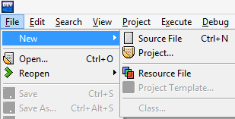Click **Start Program Bloodshed-Dev-C++ Dev-C++**

**Step 1: Source File**

1. To Open New Source file
2. Click **File** menu.
3. Bring mouse pointer to **New.**
4. Click on **Source File.**
5. New Source file will open.

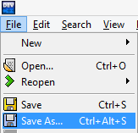

1. To Save New Source file
2. Click **File** menu.
3. Click on **Save-As.**
4. **Save file** window will pop up.
5. Naming Source File
6. Select Program path to save your **Source file.**
7. 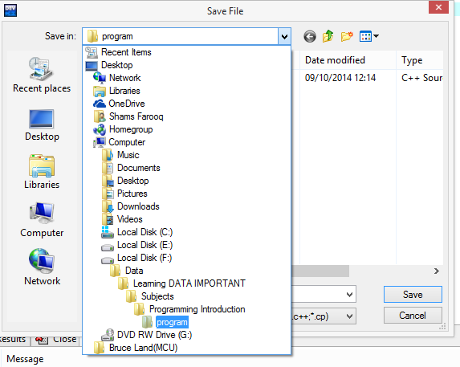Create **New Folder**.
8. Name your source file.
9. Save source file by clicking **Save**.

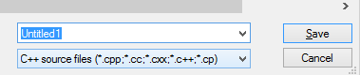

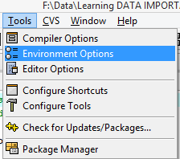**Step 2: Settings for Dev C**

1. Setting Directories.
2. Click **Tools** Menu.
3. Click on **Environment Options.**
4. **Environment Options** window should pop-up.
5. Select **Directories** Tab.
6. Give path in **User’s default directory.**
7. Press **OK.**

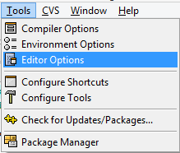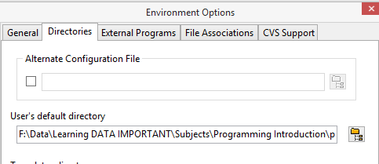

1. Setting Tab Size.
2. Click **Tools** Menu.
3. Click on **Editor Options.**
4. **Editor Options** window should pop up.
5. Select **General** tab.
6. Check **Use tab character.**
7. Press **OK** to close window.

C:\Users\Shams\AppData\Local\Microsoft\Windows\INetCache\Content.Word\New Picture.bmp

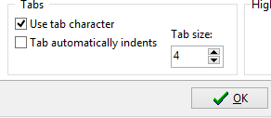

1. Inserting Default Source Code.
2. Click **Tools** Menu.
3. Click on **Editor Options.**
4. **Editor Options** window should pop up.
5. Select **Code Insertion** tab.
6. Select **Default Source** tab.
7. Check **Insert the following code in every new empty file.**
8. Write the code.
9. Press **OK.**

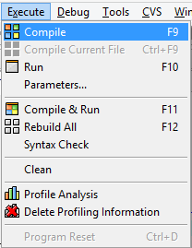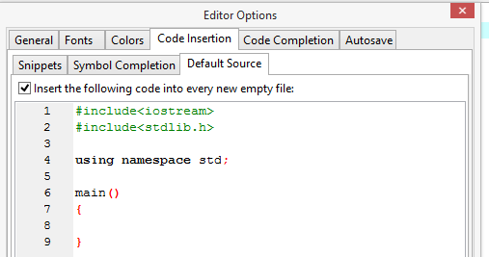

**Step 3: Run Your Program**

1. How to Compile
2. Click on **Execute** Menu**.**
3. Click on **Compile.**
4. **Compile Progress** window will pop-up.
5. How to Run
6. Click on **Execute** Menu**.**
7. Click on **Run.**

